Creating modules folders

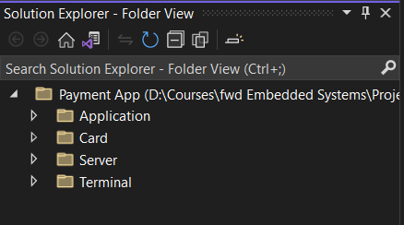

Creating .c and .h file for each module

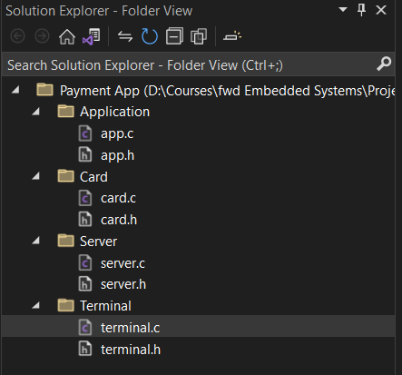

Adding header file guard

* App.h

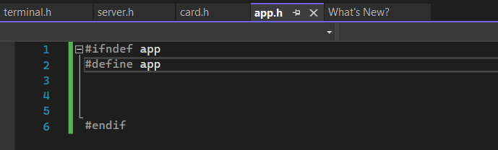

* terminal.h

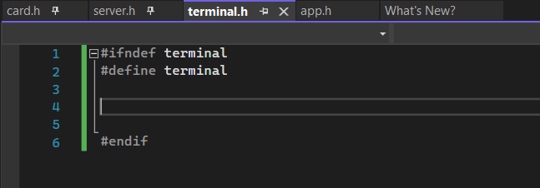

* server.h

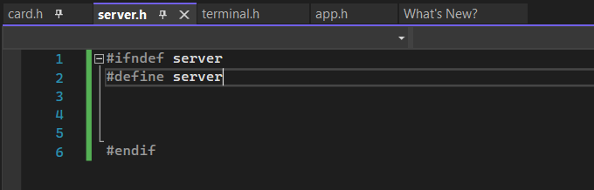

* card.h

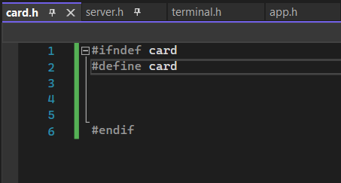

Card.h

Terminal.h

Server.h

Accounts database array

Transactions' database



Application.h

